**Introduction**

The human heart is divided into two chambers called the atria and the ventricle. In order to create a heartbeat, the SA node located in the atria will send an electrical signal which travels toward the ventricle. As the signal passes through, each chamber contract and the combination of movement of electrical impulse and subsequent contractions are what made up a heartbeat. For this lab, the goal is to observe the electrical activity of the heart by creating an electrocardiogram (ECG).

**Method**

The three components used to make an ECG were electrodes, an AD8232, and an Arduino Uno. The set up required three disposable electrodes which were clipped on to one end of the cable. The other end was plugged into a heart rate monitor equipped with low pass and high pass filters called the AD8232. The output of this analog device was, then, connected to the analog input on the Arduino. After connecting the electrodes to the body and run the program, the graph can be observed on the serial plotter of the Arduino.

**Result**

An ECG graph, typically, consists of a P wave, a QRS complex, and a T wave. Each one is based on the action performed by either the atria or the ventricle. Missing one or multiple waves usually suggest that there is some sort of problem with the heart.

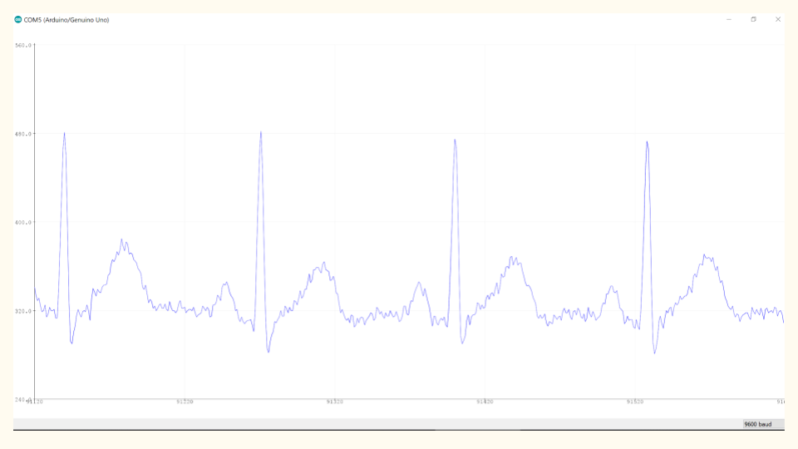

An actual ECG graph measured using the setup above

**Conclusion**

The human heart is one of the most important organs in the body. Studying the plot of voltages generated by the heart over time can provide information regarding the structure and function of the heart. This is the reason why electrocardiogram is useful in detecting heart-related issues such as arrhythmia and bradycardia.

**Code**

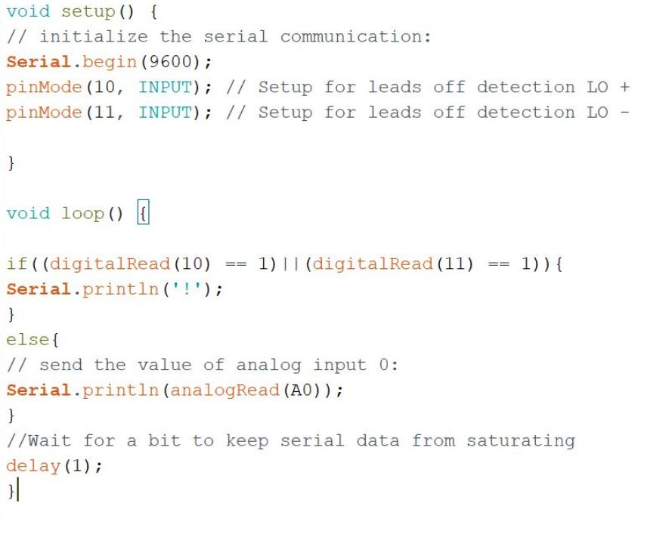

**Source**

Instructables. “Arduino Based ECG & Heartbeat Monitoring Healthcare System.” Instructables,

Instructables,24Sept.2017,https://www.instructables.com/id/ECG-Monitoring-System-by-

Using-Arduino-or-AD8232/.